Daily Epidemiology Report
22-03-2020 13:59
COVID-19 surveillance data are dynamically stored in the Washington Disease Reporting System (WDRS). The data are updated when new information about a case is entered, such as exposure information, change in address, lab data from diagnostic and routine tests, date of death, case information from medical providers, or information from other jurisdictions indicating a person has moved out of Washington. Given the dynamic nature of COVID-19 surveillance data, data reported in the past may not match data reported in present time.
For questions, please contact doh-epi-branch@doh.wa.gov or call 206-418-5500.

Summary
Total Confirmed Cases: 1996
Total Deaths: 95

Number of Individuals Tested
Result | Number of Individuals Tested | Percent of Tests
Negative | 28879 | 94%
Positive | 1996 | 6%

Positive and Negative Tests by Day
This chart and table display the number and percentage of persons with positive test results and number of persons with negative test results by day in Washington State, excluding known non-Washington State residents.
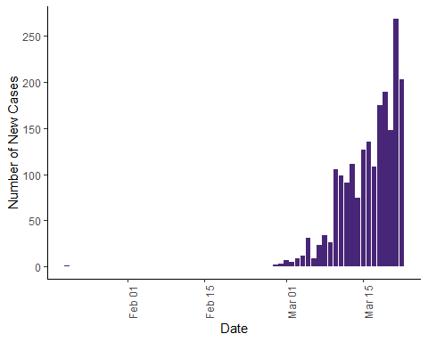
Date | Positive Tests | Negative Tests | Percent Positive Tests
09 Mar | 26 | 39 | 40%
10 Mar | 105 | 1026 | 9%
11 Mar | 99 | 862 | 10%
12 Mar | 91 | 1313 | 6%
13 Mar | 111 | 1651 | 6%
14 Mar | 74 | 1121 | 6%
15 Mar | 127 | 2329 | 5%
16 Mar | 135 | 2131 | 6%
17 Mar | 108 | 1535 | 7%
18 Mar | 175 | 2801 | 6%
19 Mar | 189 | 3448 | 5%
20 Mar | 148 | 2353 | 6%
21 Mar | 269 | 3609 | 7%
22 Mar | 203 | 3551 | 5%

Daily Reports of COVID-19 Positive and Negative Tests in Washington State by Report Date
This chart displays the number of new positive and negative test counts of COVID-19 in Washington State by day.
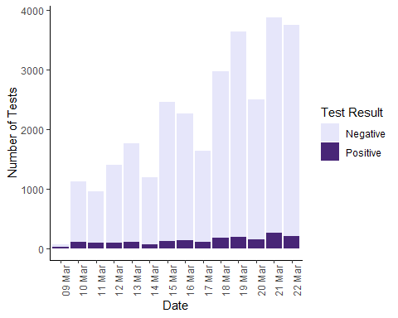

Confirmed Cases and Deaths by County
This table displays the number of laboratory confirmed (including presumptive) positive COVID-19 cases in Washington State by county. Data are preliminary and presumptive positive tests are subject to change after confirmatory testing.
County | Number of Cases | Number of Deaths
Benton County | 7 | 2
Chelan County | 3 | 0
Clallam County | 4 | 0
Clark County | 10 | 3
Columbia County | 1 | 0
Cowlitz County | 3 | 0
Franklin County | 3 | 0
Grant County | 18 | 1
Grays Harbor County | 1 | 0
Island County | 21 | 1
Jefferson County | 6 | 0
King County | 1040 | 75
Kitsap County | 18 | 0
Kittitas County | 4 | 0
Klickitat County | 4 | 0
Lewis County | 2 | 0
Lincoln County | 1 | 0
Mason County | 1 | 0
Pierce County | 107 | 1
San Juan County | 1 | 0
Skagit County | 33 | 0
Snohomish County | 480 | 10
Spokane County | 20 | 0
Stevens County | 1 | 0
Thurston County | 11 | 0
Walla Walla County | 1 | 0
Whatcom County | 14 | 2
Yakima County | 16 | 0
Number of Cases with Unassigned County: 165*
*Cases pending receipt of address information from outside labs

Confirmed Cases and Deaths by Sex
This table displays the number of laboratory confirmed (including presumptive) positive COVID-19 cases and deaths in Washington State by sex. Data are preliminary and presumptive positive tests are subject to change after confirmatory testing.
Sex at Birth | Percent of Cases | Percent of Deaths
Female | 51% | 54%
Male | 45% | 44%
Unknown | 4% | 2%

Confirmed Cases and Deaths by Age
This table displays the number of laboratory confirmed (including presumptive) positive COVID-19 cases and deaths in Washington State by age group. Data are preliminary and presumptive positive tests are subject to change after confirmatory testing.
Age Group (years) | Percent of Cases | Percent of Deaths
<19 | 2% | 0%
20-29 | 9% | 0%
30-39 | 14% | 0%
40-49 | 14% | 2%
50-59 | 17% | 6%
60-69 | 16% | 10%
70-79 | 15% | 30%
80+ | 15% | 50%

Positive and Negative Tests by County
This table displays the number of persons with positive test results and number and percentage of persons with negative test results by county in Washington State, excluding known non-Washington State residents. The ‘Positive’ count is the number of persons who have tested positive. The ‘Negative’ count is the number of persons tested whom have not had a positive lab test result.
Note that the county numbers only include results (positive or negative) for results received by WADOH that include address information on the person tested. A large number of negative results (12507) have been received from outside labs without address information. This may artificially inflate the ratio of positive to negative results in each county.
County | Positive Tests | Negative Tests | Percent Positive Tests
Adams County | 0 | 14 | 0%
Asotin County | 0 | 13 | 0%
Benton County | 5 | 148 | 3%
Chelan County | 4 | 99 | 4%
Clallam County | 3 | 75 | 4%
Clark County | 12 | 283 | 4%
Columbia County | 1 | 14 | 7%
Cowlitz County | 3 | 74 | 4%
Douglas County | 0 | 44 | 0%
Ferry County | 0 | 25 | 0%
Franklin County | 2 | 61 | 3%
Garfield County | 0 | 3 | 0%
Grant County | 18 | 88 | 17%
Grays Harbor County | 1 | 66 | 1%
Island County | 24 | 191 | 11%
Jefferson County | 6 | 41 | 13%
King County | 1048 | 6894 | 13%
Kitsap County | 16 | 422 | 4%
Kittitas County | 4 | 152 | 3%
Klickitat County | 3 | 22 | 12%
Lewis County | 2 | 66 | 3%
Lincoln County | 1 | 18 | 5%
Mason County | 1 | 96 | 1%
Okanogan County | 0 | 45 | 0%
Pacific County | 0 | 10 | 0%
Pend Oreille County | 0 | 19 | 0%
Pierce County | 109 | 2233 | 5%
San Juan County | 1 | 39 | 2%
Skagit County | 33 | 149 | 18%
Skamania County | 0 | 6 | 0%
Snohomish County | 482 | 2929 | 14%
Spokane County | 20 | 867 | 2%
Stevens County | 1 | 38 | 3%
Thurston County | 11 | 521 | 2%
Wahkiakum County | 0 | 4 | 0%
Walla Walla County | 1 | 85 | 1%
Whatcom County | 18 | 300 | 6%
Whitman County | 0 | 33 | 0%
Yakima County | 20 | 185 | 10%
Total Assigned to County | 1850 | 16372 | 10%
Total Unassigned to County | 146 | 12507 | 1%

Positive and Negative tests by Age Group
This table displays the number of persons with positive test results and number of persons with negative test results by age group in Washington State, excluding known non-Washington State residents. The ‘Positive’ count is the number of persons who have tested positive. The ‘Negative’ count is the number of persons tested whom have not had a positive lab test result.
Age Group (years) | Positive Tests | Negative Tests | Percent Positive Tests
0-4 | 5 | 1196 | 0%
5-17 | 20 | 1686 | 1%
18-44 | 591 | 12130 | 5%
45-64 | 635 | 8626 | 7%
65-79 | 433 | 3406 | 11%
80+ | 289 | 1381 | 17%
Unknown | 7 | 34 | 17%

Number of Deaths* for Confirmed COVID-19 Cases
This table and chart shows the number of deaths by date of death based on death certificate data.
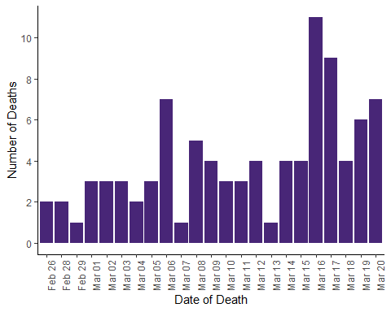
Date of Death | Number of Deaths
Feb 26 | 2
Feb 28 | 2
Feb 29 | 1
Mar 01 | 3
Mar 02 | 3
Mar 03 | 3
Mar 04 | 2
Mar 05 | 3
Mar 06 | 7
Mar 07 | 1
Mar 08 | 5
Mar 09 | 4
Mar 10 | 3
Mar 11 | 3
Mar 12 | 4
Mar 13 | 1
Mar 14 | 4
Mar 15 | 4
Mar 16 | 11
Mar 17 | 9
Mar 18 | 4
Mar 19 | 6
Mar 20 | 7
Number of Cases with Unassigned Date of Death: 10
*Deaths pending receipt of information from local health jurisdictions

COVID-like Illness (CLI) Hospitalizations
- CLI hospitalizations are significantly elevated in all adults. A sharp increasing trend in CLI hospitalizations has been noted for the past 3 weeks. Pneumonia hospitalizations are also significantly elevated in adults and has exceeded levels from the peak of the influenza season at the end of 2019. This observation is new as of week 12 (week ending 3/21).
Below is a graph of the daily percent of hospital admissions for CLI and a table of daily CLI hospital admission counts for the past 7 days.
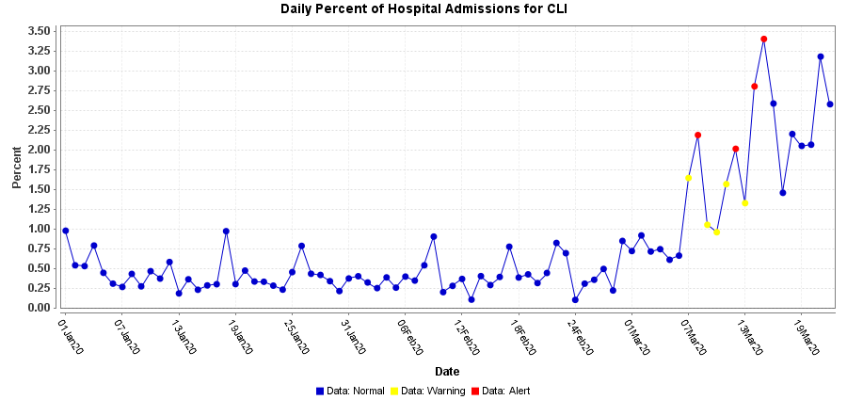
Admission Date | Number of CLI Hospitalizations | Total Number of Hospitalizations | Percent CLI Hospitalizations
Mar 15 | 37 | 1088 | 3%
Mar 16 | 52 | 2012 | 3%
Mar 17 | 28 | 1924 | 1%
Mar 18 | 41 | 1864 | 2%
Mar 19 | 34 | 1660 | 2%
Mar 20 | 34 | 1647 | 2%
Mar 21 | 28 | 881 | 3%
Mar 22 | 6 | 233 | 3%
Data Notes: COVID-like illness (CLI) includes visits with symptoms of fever/chills AND respiratory symptoms (such as cough, difficulty breathing or shortness of breath).
Analyses are based on information reported to the Rapid Health Information NetwOrk (RHINO). At the date of this report, 84/100 (84%) Emergency Departments in the state submit data to RHINO. Data are preliminary and may change.

