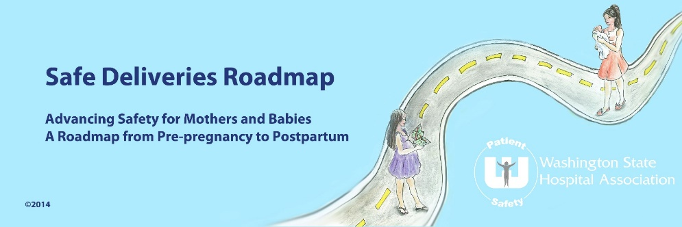

Safe Deliveries Roadmap Safe Table Learning Collaborative©
“Maternity Watch” Program Participation Form

(organization’s name) is interested in participating in the Safe Deliveries Roadmap “Maternity Watch” program.

The “Maternity Watch” program goal is to provide hospital teams with evidence-based education, tools and resources to optimize early recognition and response to maternal warning signs for severe hypertension/preeclampsia, maternal hemorrhage, sepsis and cardiopulmonary events, reducing the incidence of severe maternal morbidity and mortality.

Program leadership and subject matter experts will provide the following support to participating organizations:
- Best practice recommendations based on the latest medical evidence
- Implementation Guide with tools and resources
- Severe Maternal Morbidity measure reports (CHARS)
- A peer network to maximize learning
- Monthly learning sessions and coaching from national and local leaders
- Alignment with other State-wide efforts to address severe maternal morbidity and mortality

Participation requirements are:
- CEO sponsorship
- Clinical leader participation (administrative and medical)
- Attendance at virtual monthly meetings
- Signed participation form

CEO Name:
Signature: | Date:
Obstetric Medical Leader Name:
Signature: | Date:
Obstetric Administrator Name:
Signature: | Date:
Project Lead Name:
Signature: | Date:

Note: one person may fulfill more than one of the roles listed above.

Please email the completed form to: Cindy Ferguson (cindyf@wsha.org)

Questions? Contact Janine Reisinger (janiner@wsha.org) 206-216-2869

