COVID-19 Vaccine Patient Acknowledgment

Patient Name (Last, First): _______________________________________________________________ DOB: ____/____/________

Phone: ____________________ Mobile Phone: ___________________________Email: ____________________________________
(This information will be used to contact you for your second dose reminder.)

Address: _______________________________________ City, State, Zip Code: ___________________________________________

Information collected in this section helps ensure we deliver equitable and patient-centered care:
Sex listed at birth (check one):
Male: □ | Female: □

Gender identity (check one):
Male: □ | Female: □ | Non-Binary □ | Unspecified/Indeterminant: □

Ethnicity (Check one):
Hispanic or Latino (Including Spanish, Mexican, Puerto Rican, Cuban, etc. □ | Not-Hispanic A person not of Spanish culture or origin □

Race: (Check all that apply):
Black or African American □  White □ | Asian □  American Indian or Alaska Native □ | Hawaiian or Pacific Islander □

Insurance Information:

Insurance company: _______________________________________ Are you the primary card holder? Y N

If no, what is the primary card holders name and date of birth? ___________________________________________

Cardholder ID: __________________________________________ Rx Group ID: ____________________________

BIN: _______________________ PCN: __________________________

Are you Medicare eligible? Y N If yes, Medicare Part A/B number: ___________________________

If you are not insured and you do not want to pay for administration of the vaccine yourself, you must provide the information below. If you do not provide this information you may be billed for vaccine administration.

I do not have any insurance, including but not limited to Medicare, Medicaid, or any other private or government-funded health benefit plan. In order to have your vaccine administration fee paid for by the United States Health Resources & Services Administration’s COVID-19 Program for Uninsured Patients please provide (a) a valid Social Security number, or (b) state identification number and state of issuance, or (c) a driver’s license number and the state of
issuance: _______________________________________

Acknowledgements:
- I made the choice to get the COVID-19 vaccine on my own and freely. I know I have the option to refuse the vaccine. I ask that the vaccine be given to me, or to the person named above for whom I can make this request. I was given the (Fact Sheet for Vaccine Recipients and Caregivers) for this vaccine. The fact sheet has information about side effects and adverse reactions. I read or had read to me the information provided about the COVID-19 vaccine.

- I know the Food and Drug Administration (FDA) has authorized the emergency use of this vaccine. I know it is not a fully licensed FDA vaccine. I had the chance to ask questions that were answered to my satisfaction. I now know about the vaccine, alternatives, benefits, and risks, to the extent they are known and unknown at this time.

- I know that I must stay in the vaccine area or an area told to me by my health care provider after I receive my immunization so I am near my health care provider if I have any adverse reactions.. If I have a history of certain allergic reaction(s), I must stay for 30 minutes. If I do not have a history of such an allergic reaction(s), I must stay for 15 minutes.

- I know that if I have a severe allergic reaction, including difficulty breathing, swelling of my face and/or throat, a fast heartbeat, a bad rash all over my body or dizziness and weakness I should call 9-1-1 or go to the nearest hospital. I know I can call my health care provider if I have any side effects that bother me or do not go away.

- I was asked to join the V-SAFE program. The program does health checks on the people who get the COVID-19 vaccine. I know I should report vaccine side effects to FDA/CDC Vaccine Adverse Event Reporting System (VAERS) at 1-800-822-7967 or https://vaers.hhs.gov/reportevent.html.

- I know I must get two doses of the COVID-19 vaccine and receive the same vaccine each time. I know that with all vaccines there is no promise I will become immune (not get the virus) or that I will not have side effects. I know I may choose to not get the second dose of the vaccine. But if I do not get the second dose, the chance that I will become immune may go down.
Authorization to Request Payment: I authorize the organization providing my vaccine to release information and request payment. I certify that the information given by me in applying for payment under Medicare or Medicaid or the HRSA COVID-19 Program for Uninsured Patients, is correct. I authorize release of all records to act on this request. I request that payment of authorized benefits be made on my behalf.

Disclosure of Records: I understand the organization providing my vaccine may be required to or may voluntarily disclose my vaccine-related health information to my primary care physician, my insurance plan, health systems and hospitals, and state or federal registries or other public health authorities, for purposes of treatment, payment or health care operations. I also understand the organization providing my vaccine will use and disclose my health information as described in its Notice of Privacy Practices which I may receive upon request or find on its website. If I am an employee of [insert name of health care provider] I understand that it will keep records of this vaccination for me in [insert name of electronic health record] and may keep my vaccination records in [insert name of health care provider]’s employee occupational health records, to the extent required or permitted by law.

Patient (or Parent/Guardian/Authorized Representative) Signature: ______________________________ Date: __________________

Name of Parent, Guardian or Authorized Representative: ______________________________________ Date: __________________

If you are signing on behalf of the patient, you are stating that you are authorized to make the required decisions on behalf of the patient.

All sections below are for official use only:

Vaccine Administration Information for Immunizer:
Administration date: _____________________ Administration time: _______
CVX (Product): _____________________________________________________
Dose number: ______________________________________________________
IIS Recipient ID: ____________________________________________________
IIS vaccination event ID: ______________________________________________
Lot number: ________________________________________________________
Unit of Use MVX (Manufacturer): ________________________________________
Sending organization: _________________________________________________
Vaccine administering provider suffix: ____________________________________
Vaccine administering site on the body: Left deltoid □ Right deltoid □ Other □ (indicate location) ________
Vaccine expiration date: _________________
Vaccine route of administration: ________________________________________
Vaccination series complete (date): ______________________________________
Fact Sheet for Vaccine Recipients and Caregivers version date: _______________________

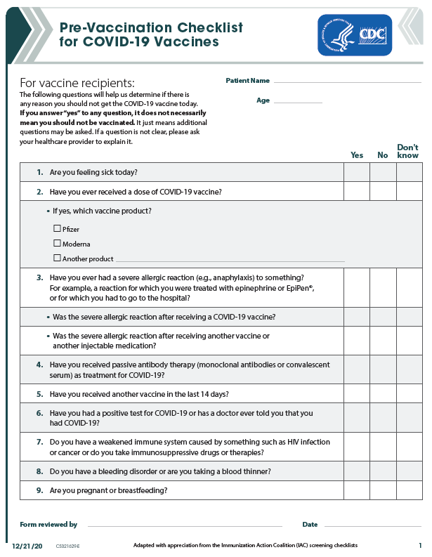

Notes about this form:
- This form should only be provided to a patient if it is accompanied by the Fact Sheet for Vaccine Recipients and Caregivers
  - Moderna: https://www.fda.gov/media/144638/download
  - Pfizer BioNTech https://www.cvdvaccine.com/
- This form should only be used by clinicians well versed in the CDC’s provider education materials who are able to counsel patients who answer “yes” to the screening questions or make referrals for counseling for those patients. See here for more information:
  - Full CDC Pre-Vaccination Check List with information for health care professionals: https://www.cdc.gov/vaccines/covid-19/downloads/pre-vaccination-screening-form.pdf
  - Interim Clinical Considerations for Use of mRNA COVID-19 Vaccines Currently Authorized in the United States: https://www.cdc.gov/vaccines/covid-19/info-by-product/clinical-considerations.html
- This form is intended as a resource. It is not a mandatory form.
- This form was developed based on the best available information at the time it was created. Its accuracy is not guaranteed. Organizations and individuals choosing to use this form should do so in consultation with their own clinicians and attorneys.
- This form is subject to update without notice.
- For convenience, some elements in this form may be pre-recorded in electronic health records or other databases.
- Resources used in creating this form:
  - COVID-19 Vaccination Training Programs and Reference Materials for Healthcare Professionals for information about screening questions and Fact Sheet for Vaccine Recipients and Caregivers https://www.cdc.gov/vaccines/covid-19/downloads/COVID-19-Clinical-Training-and-Resources-for-HCPs.pdf
  - CDC Vaccine Information:
    - Pfizer BioNTech: https://www.cdc.gov/vaccines/covid-19/info-by-product/pfizer/index.html
    - Moderna: https://www.cdc.gov/vaccines/covid-19/info-by-product/moderna/index.html
  - V-Safe Program; https://www.cdc.gov/coronavirus/2019-ncov/vaccines/safety/vsafe.html
  - COVID-19 Vaccination Communication Toolkit: https://www.cdc.gov/vaccines/covid-19/health-systems-communication-toolkit.html
  - Washington State’s COVID-19 Vaccine Plan for vaccine reporting requirements. https://www.doh.wa.gov/Portals/1/Documents/1600/coronavirus/WA-COVID-19-Vaccination-Plan.pdf
  - For Demographic Information:
    - Washington State CHARS Manual: https://www.doh.wa.gov/Portals/1/Documents/5300/CHARSManual-UB04-5010.pdf
    - Race Ethnicity Language Data Collection Best Practices: http://forces4quality.org/af4q/download-document/6011/Resource-validated_final_rel_data_collection_best_practice_guidelines_updated_11-28.pdf
    - Collecting Sexual Orientation and Gender Identity Information: https://www.cdc.gov/hiv/clinicians/transforming-health/health-care-providers/collecting-sexual-orientation.html

